The used formulas for each method:

Composite Trapezoidal rule:

$$I=\frac{h}{2}[f\left(x_{0}\right)+2\sum_{i=1}^{i=n-1}{f\left(x_{i}\right)}+f\left(x_{n}\right)]$$

Multiple Simpson rule:

$$I=\frac{h}{3}[f\left(x_{0}\right)+4\sum_{i=1,3,5}^{i=n-1}{f\left(x_{i}\right)}+2\sum_{i=2,4,6}^{i=n-2}{f\left(x_{i}\right)}+f\left(x_{n}\right)]$$

Midpoint Integral rule:

$$x_{i}=a+\left(i-\frac{1}{2}\right)h$$

$$I=h×\sum_{i=1}^{n}{f(x_{i})}$$

Trapezoidal Rule test:

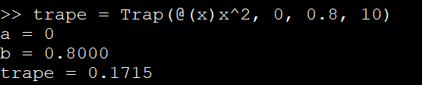

At $a=0,b=0.8,n=10, f\left(x\right)=x^{2}$

Simpson’s Rule test:

At

Midpoint Rule test:

At

Names and Codes:

Allaa Mohamed Mahmoud Sayed 2027056

Adham Mohamed Kandil 1927217